**VisionForge**

Mentors: Isha Jain, Karan Mundhra, Umang Sinha

Due date: 31 Dec, 2023

Due time: 11:59PM

**Mini Project-1**



Create a Verilog design for a clock with an alarm, incorporating the following features.

● Clock Generation

● Initializing clock time to a particular value

● Setting time for alarm

● Enabling and disabling alarm

● Stopping alarm

Presented here is the Block Diagram for the clock system 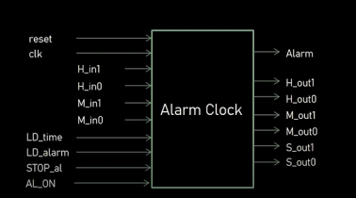

1

Here is the Flow chart illustrating the operations of the clock system

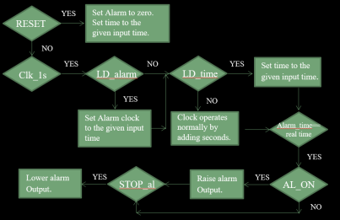Collaborative undertake and submit this project as a group!

2